Project Planning Phase – Garage Management System (GMS)
The Project Planning Phase is focused on establishing the structural foundation of the Garage Management System (GMS) within the Salesforce environment. This phase defines user access, roles, interface components, and navigation — ensuring a secure, organized, and efficient workflow setup before the system design and automation phases begin.
Objective
The goal of the Project Planning Phase is to organize the Salesforce workspace, set up access hierarchies, and configure navigation components to enable a collaborative, role-based working environment for users such as managers, salespersons, and administrators.
Key Activities
1. Tabs Creation
- Purpose: Tabs act as the primary navigation interface for interacting with data objects.
- Types of Tabs:
  - Custom Tabs: Created for custom Salesforce objects like Customer Details, Appointments, Service Records, and Billing Details & Feedback.
  - Web Tabs: Used to integrate web content or external applications.
  - Visualforce Tabs: Display custom Visualforce pages.
  - Lightning Component Tabs: Add Lightning components to app navigation.
  - Lightning Page Tabs: Add Lightning Pages for mobile navigation.
- Outcome: Created separate tabs for all primary GMS objects for easy access and data entry.
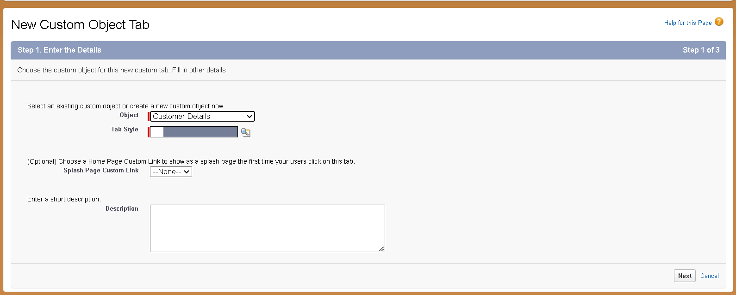
2. The Lightning App Creation
- Purpose: The Garage Management Application acts as a central workspace for users.
- Process:
  - Created through App Manager in Salesforce.
  - Added navigation items such as Customer Details, Appointments, Service Records, Billing Details & Feedback, Reports, and Dashboards.
  - Assigned to the System Administrator profile.
- Outcome: A unified and customizable app environment with simplified navigation and access to all essential objects.
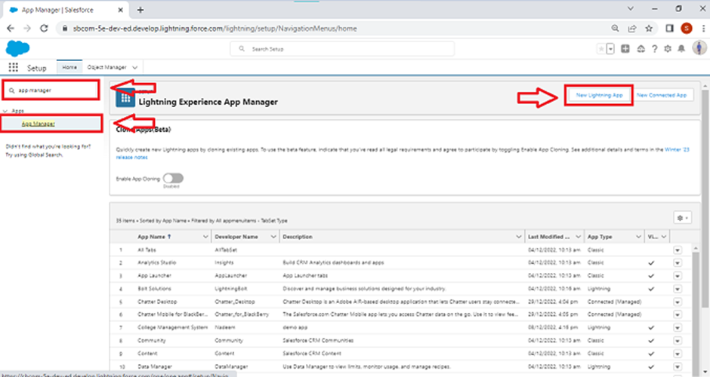

3. Profiles Setup
- Purpose: Profiles control what users can view, edit, and manage.
- Types of Profiles:
  - Standard Profiles: Include default Salesforce roles like System Administrator, Standard User, etc.
  - Custom Profiles: Created specifically for project needs.
- Custom Profiles Created:
  - Manager Profile: Cloned from Standard User; given access to all custom objects, 8-hour session timeout, and password never expires.
  - Salesperson Profile: Cloned from Salesforce Platform User; restricted access based on assigned roles.
- Outcome: Defined specific permissions for different users ensuring data security and functional segregation.

4. Role & Role Hierarchy
- Purpose: Roles determine record-level visibility and hierarchy-based access.
- Structure Implemented:
  - CEO → Manager → Salesperson
- Outcome: Created a clear access hierarchy to ensure controlled visibility and smooth data flow among organizational levels.

5. User Accounts
- Purpose: Enable individual access to Salesforce with defined credentials and permissions.
- Process:
  - Created users for Manager and Salesperson roles.
  - Each user linked with appropriate profile and license type (Salesforce or Salesforce Platform).
  - Minimum of three users created for demonstration.
- Outcome: Functional user accounts ready for testing and interaction.

6. Public Groups
- Purpose: Simplify data sharing and collaboration among multiple users.
- Implementation:
  - Created a group named “Sales Team” including all Salesperson roles.
- Outcome: Enhanced data access control and improved collaboration among sales users.
Outcome of the Planning Phase
By the completion of the Project Planning Phase, the Salesforce environment for the Garage Management System was fully structured with:
- Defined user hierarchy and roles.
- Secure and role-based access permissions.
- Custom navigation tabs and centralized Lightning App.
- Collaborative group setup for efficient data sharing.
This phase ensured that the platform was properly organized, secure, and user-friendly, serving as the foundation for the Design and Development Phases that follow.

